 | 12 Editors - Geometry Node Editor
Table of content
Geometry Nodes Editor 2
Navigating in the Geometry Nodes Editor viewport 2
Hotkeys 2
Node header icons 3
Node context menu 3
Duplicate 3
Rename 3
Delete 3
Copy 3
Paste 3
Delete with Reconnect 4
Make Links 4
Make and Replace Links 4
Detach Links 4
Group 4
Ungroup 5
Edit Group 5
Hide 5
Toggle Node Mute 5
Toggle Node Preview 5
Toggle Hidden Node Sockets 6
Toggle Node Options 6
Collapse and Hide Unused Sockets 6
Quick Favorites menu 6

Geometry Nodes Editor
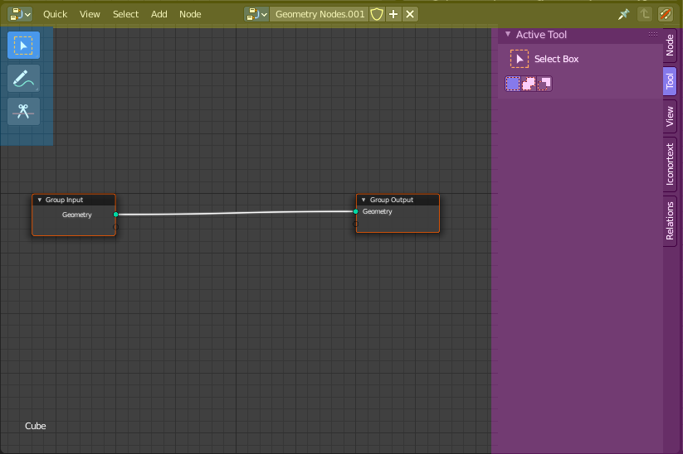

The geometry node editor is an editor where you can modify the geometry of objects by nodes.
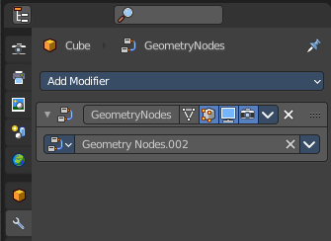
When you add a node then a modifier gets added too. Geometry nodes are tied to this modifier.
The editor is divided into several areas has several tool areas.
Yellow – Header
Blue - Tool Shelf
Pink - Sidebar
Note that the shader editor does not have a tool area above the header. All tool settings are in the sidebar in the Tool tab.

Navigating in the Geometry Nodes Editor viewport

Hotkeys
Pan the view - MMB
Zoom - Mouse Wheel, MMB+CTRL, Numpad + / -
View All - Home

Node header icons

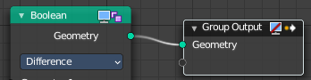
The header of a node contains usually two icons. The icon at the right is the node icon.

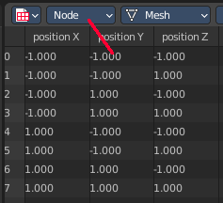
The icon left from it is a toggle. It allows to show the output at this point of the node tree in the spreadsheet editor.

Node context menu

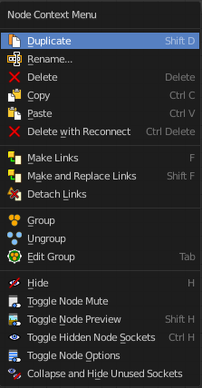
When you double right click into the viewport, then you will open a menu. The UV Context menu. Its content is to 100% double content to already existing menus. And it is despite the name not contextual.

Duplicate
Duplicates the selected nodes.

Rename
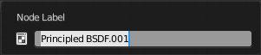
Allows you to rename the current active node. A popup opens up where you can type in another name.

Delete
Deletes the selected nodes. All Connections gets removed.

Copy
Copies the selected nodes.

Paste
Pastes the copied nodes.

Delete with Reconnect
Deletes the selected nodes. Existing connections gets bypassed as if the node would not have existed.

Make Links
Tries to connect nodes where it makes sense. For example, the BSDF output of a Principled shader with the Surface input of the Material Output node.

Make and Replace Links
Same as Make Links. But it will replace existing links.

Detach Links
Removes all connections from the selected node, but tries to reconnect the remaining nodes.

Group
Groups the selected nodes together.
Select the nodes that you want to group together. Choose Make Group. You will now see a green background. This indicates that the group is created, and that you are in edit mode for the group now.



To exit the group edit mode press Tab key, or choose Toggle Edit Group menu item in the sidebar in the Relations tab in the Group panel. That way you can also enter the Group Edit mode again.




There is a third way to enter the group edit mode. Click at the right upper icon of the group node.


A group can be further collapsed by clicking at the triangle button in the upper left corner.


The group can be renamed in the sidebar in the Item tab and in the Properties tab in the Node panel.

Ungroup
Removes the selected nodes from a group.

Edit Group
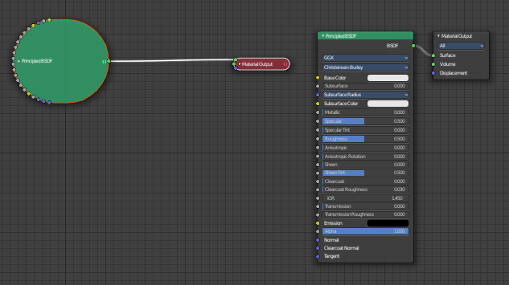
Edits a group of nodes.

Hide
Collapses the node display. Left hidden, right the original nodes.

Toggle Node Mute
Makes the current selected node active or inactive. This feature does not work with the material output node.

Toggle Node Preview
No idea. It is not to find out what gets previewed under what circumstances. And the feature is not to find in the Blender manual.

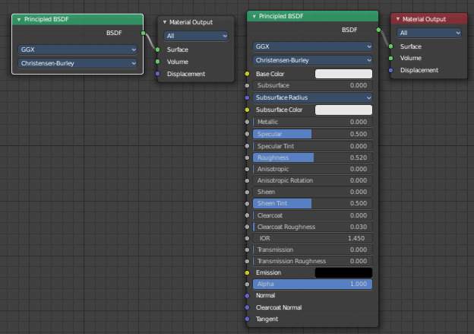
Toggle Hidden Node Sockets
Shows or hides the node sockets.

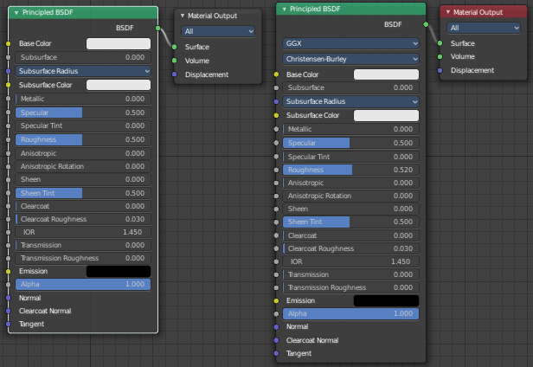
Toggle Node Options
Shows or hides the node options.

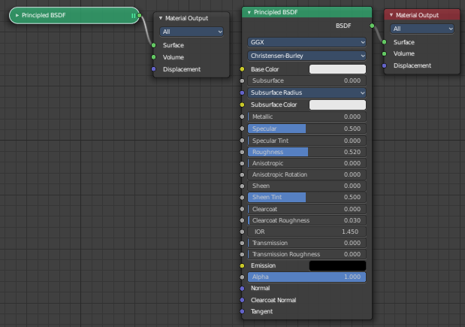
Collapse and Hide Unused Sockets
Shows or hides unused sockets.

Quick Favorites menu


When you right click at a menu or a button, then a right click menu will open. Tools have usually a Add to Quick Favorites menu entry.

The Quick Favorites Menu is empty by default. With Add to Quick favorites you can add this menu to the Quick menu.

In the 3D view we have a menu called Quick in the header, which shows this content then. In the Image Editor you can just call it with its hotkey. Q. It has no regular menu entry here.

